Global Classroom

Design Documentation

&

Final Requirements

DT282/3



Student Names & Numbers:

* Eoin Smyth [C14427202@mydit.ie](mailto:C14427202@mydit.ie)
* Robert Wijntjes [C14356786@mydit.ie](mailto:C14356786@mydit.ie)
* Jake Young [C14706715@mydit.ie](mailto:C14706715@mydit.ie)
* Elliot Igoe [C14733411@mydit.ie](mailto:C14733411@mydit.ie)
* Eryk Szlachetka [C14386641@mydit.ie](mailto:C14386641@mydit.ie)

Due Date: 27/02/17

Extension Due Date: 03/03/17

Table of Contents

Use Case’s and Narratives 3

Webpage & App - Login and Register use case diagram 3

Actors 4

Triggers 4

Preconditions 4

Post-conditions 4

Normal Flow 4

Alternative Flows 4

1.1 4

5.1 4

App - Login & View Voting Poll 5

Actors 5

Triggers 5

Preconditions 6

Post-conditions 6

Normal Flow 6

Alternative Flow 6

13.1 6

Webpage - Create a new poll use case diagram 7

Actors 8

Triggers 8

Preconditions 8

Post-conditions 8

Normal Flow 9

Alternative Flow 9

4.1 9

Webpage - Creating and Viewing Voting Poll Use-Case Diagram 9

Actors 10

Triggers 10

Preconditions 10

Post-conditions 10

Normal Flow 10

Alternative Flow 11

3.1 11

Analysis Diagram 11

Registration 12

Login 12

Login 12

Enter Poll Information 12

Enter Poll Information 13

View Poll 13

Improper Sequence Diagram 13

Sequence Diagram 14

# Use Case’s and Narratives

## Webpage & App - Login and Register use case diagram

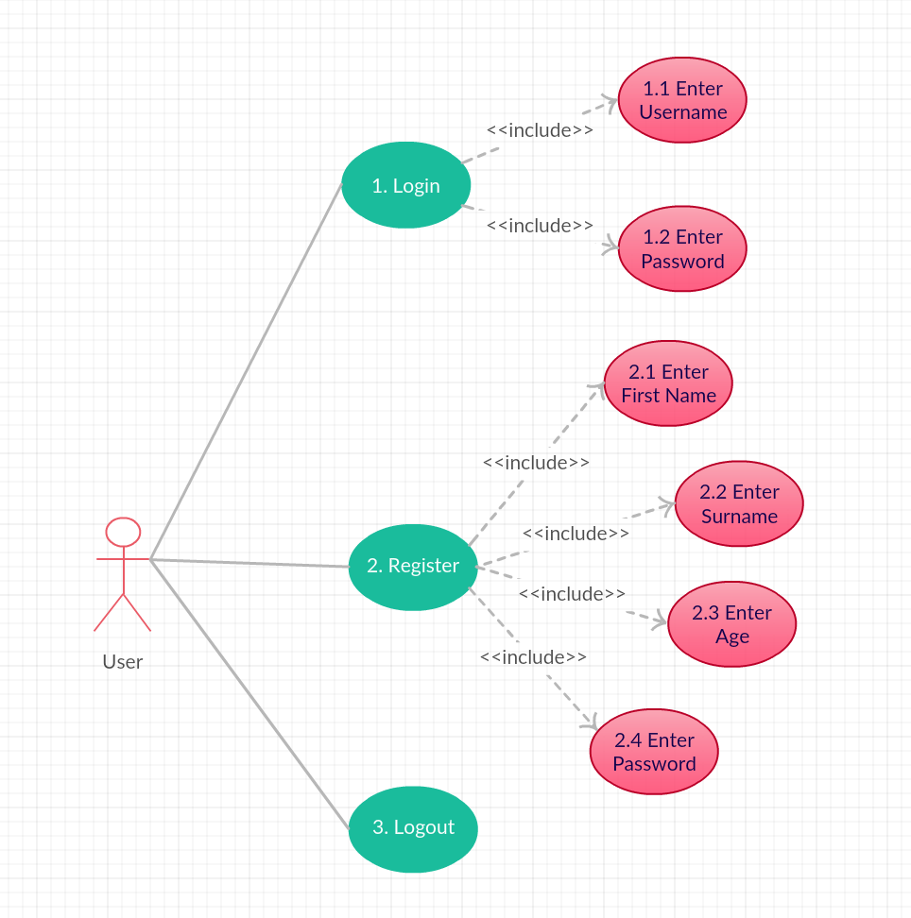

### Actors

* Registered User
* New User

### Triggers

* The user indicates that she wants to login

### Preconditions

* User is registered

### Post-conditions

* The user will be registered in the system

### Normal Flow

1. The user will indicate she wants to login
2. The system will present the login page
3. The system will highlight the login details which must be filled in
4. The user will enter her login details
5. The system will verify the users login details are valid in the database
6. The system will then send a confirmation message to the user
7. The main menu page will then be displayed
8. End of use-case

### Alternative Flows

1.1The user is brought to the login page. However, the user is new to the system and needs to be registered

1. The user will indicate she wants to register a new account
2. The system will open the registration page
3. The system will highlight the details which need to be filled in
4. The user will enter the required details
5. The system will retrieve the users details from the registration page
6. The system will create a new user account for the user
7. The system will display a registration confirmation message to the user
8. The system will open the login page
9. The user will then be prompted to enter the new login details (username, password)
10. End of use-case

5.1 The system will attempt to verify the user’s credentials with the database. However, the database doesn’t recognize this user

1. The system cannot find the users details in the database
2. The system will return an error message with reasons for error
3. The system will re-display the login page
4. The user will be prompted to renter login details
5. End of use-case

## App - Login & View Voting Poll

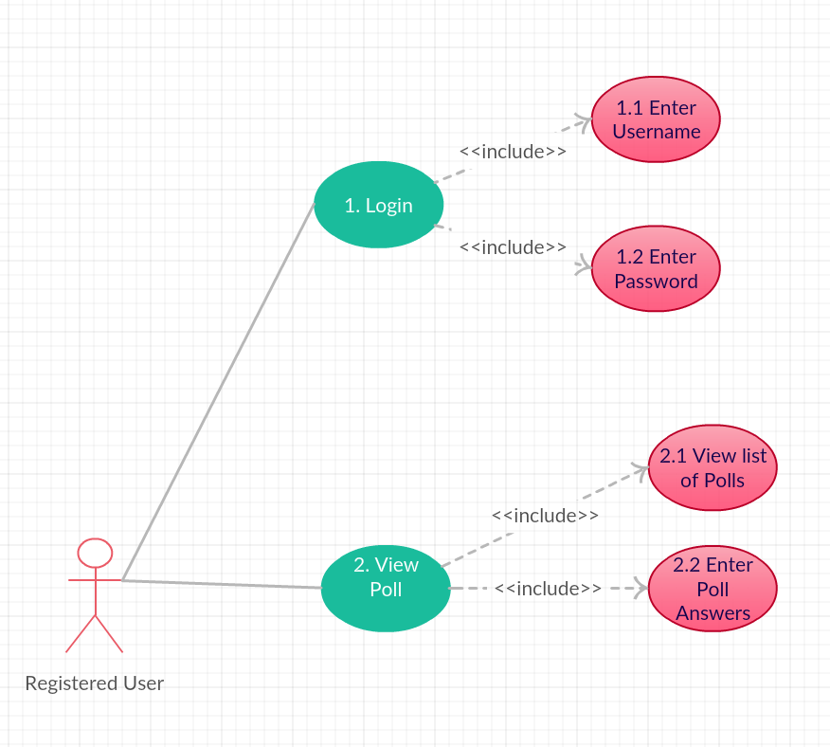

### Actors

* Registered User

### Triggers

* The user wants to login and vote through the application

### Preconditions

* The user will be registered in the system
* The user is using a mobile device which is Android compatible

### Post-conditions

* The user will be able to access the voting poll application
* The user can view the list of different voting polls
* The user can vote

### Normal Flow

1. The user will indicate she wants to login
2. The system will present the login page
3. The system will highlight the login details which must be filled in
4. The user will enter her login details
5. The system will verify the users login details are valid in the database
6. The system will then send a confirmation message to the user
7. The main menu page will then be displayed
8. The user will indicate to view the available different voting polls
9. The system will open the voting poll page
10. The system will open the selected voting poll
11. The user will enter poll answers into the voting poll
12. The user will indicate to finish the voting poll
13. The system will enter details entered by the user into the poll in the system
14. The system will display a confirmation of submission message to the user
15. The system will direct the user to the main menu
16. End of use-case

### Alternative Flow

13.1The user enters the voting poll answers in to the poll. However, the answers are not sent to the database due to a connection error. Instead, the app displays a connection error message to the user and directs the user to the main page.

1. The voting poll details are not sent to the database
2. The connection between the app and database is disconnected so, the systems displays a connection error message to the user
3. The user receives the connection error message
4. The user is directed back to the main menu list
5. End of use-case

## Webpage - Create a new poll use case diagram

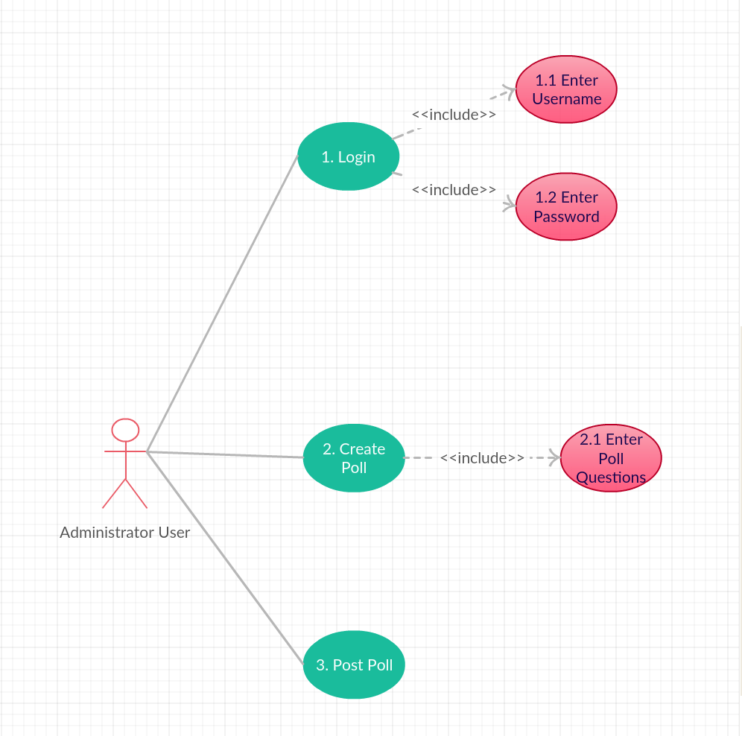

### Actors

* Registered User

### Triggers

* The user will indicate to create a new poll

### Preconditions

* The user must be registered and logged into system
* The user must be granted administrator rights

### Post-conditions

* The user will have created a new poll
* The users poll will be declared open to the public or else privatised

### Normal Flow

1. The user will login using the required credentials (username, password)
2. The system will open the main menu page
3. The user will indicate she wants to create a new poll
4. The system will verify the user is an administrator
5. The system will open the create voting poll page
6. The user will fill in the poll’s details for the questions
7. The user will choose to allow the poll to be public or private
8. The system will post the poll to be viewed and filled in by registered users
9. End of use-case

### Alternative Flow

4.1 The user would like to create a new poll. However, the user doesn’t have the administration rights to create a new poll

1. The system will respond to the user with an error message (the user doesn’t have administration permission)
2. The system will open the main menu page
3. End of use-case

## Webpage - Creating and Viewing Voting Poll Use-Case Diagram

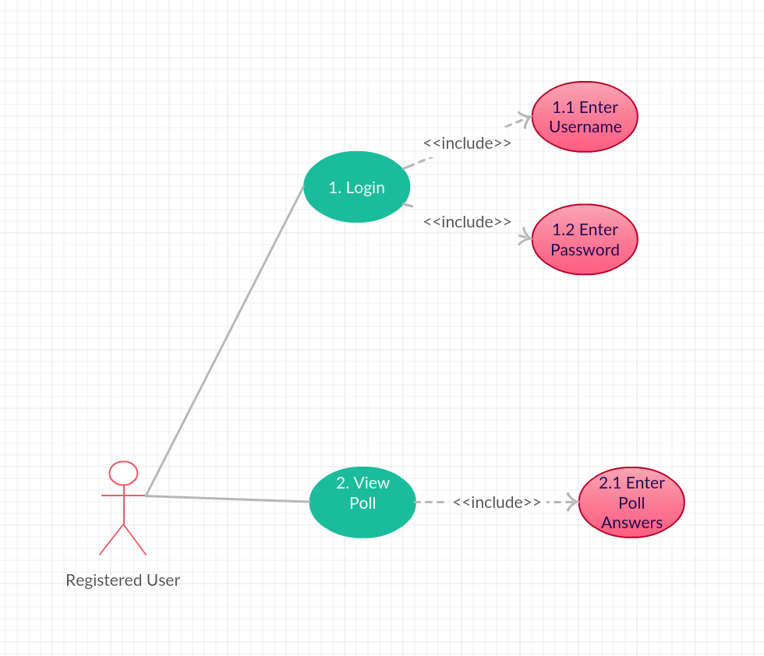

### Actors

* Registered User

### Triggers

* The user will indicate that she would like to view a poll
* The user will indicate that she would like to enter a poll

### Preconditions

* The user is registered in the database
* The user hasn’t entered into this poll before

### Post-conditions

* The user will have entered details into the poll

### Normal Flow

1. The user will login using the required credentials (username, password)
2. The system will open the main menu page
3. The user will indicate to view poll
4. The system will open the view voting poll page
5. The user will have access to viewing the finished voting poll
6. End of use-case

### Alternative Flow

3.1 The user would like to enter into a voting poll instead of viewing a voting poll

1. The user will indicate to enter a voting poll
2. The system will open the voting poll page with polls available to enter
3. The user will select the desired voting poll
4. The system will open the selected voting poll
5. The user will enter poll answers into the voting poll
6. The user will indicate to finish the voting poll
7. The system will enter details entered by the user into the poll in the system
8. The system will display a confirmation of submission message to the user
9. The system will direct the user to the main menu
10. End of use-case

# Analysis Diagram

## Registration

## Login

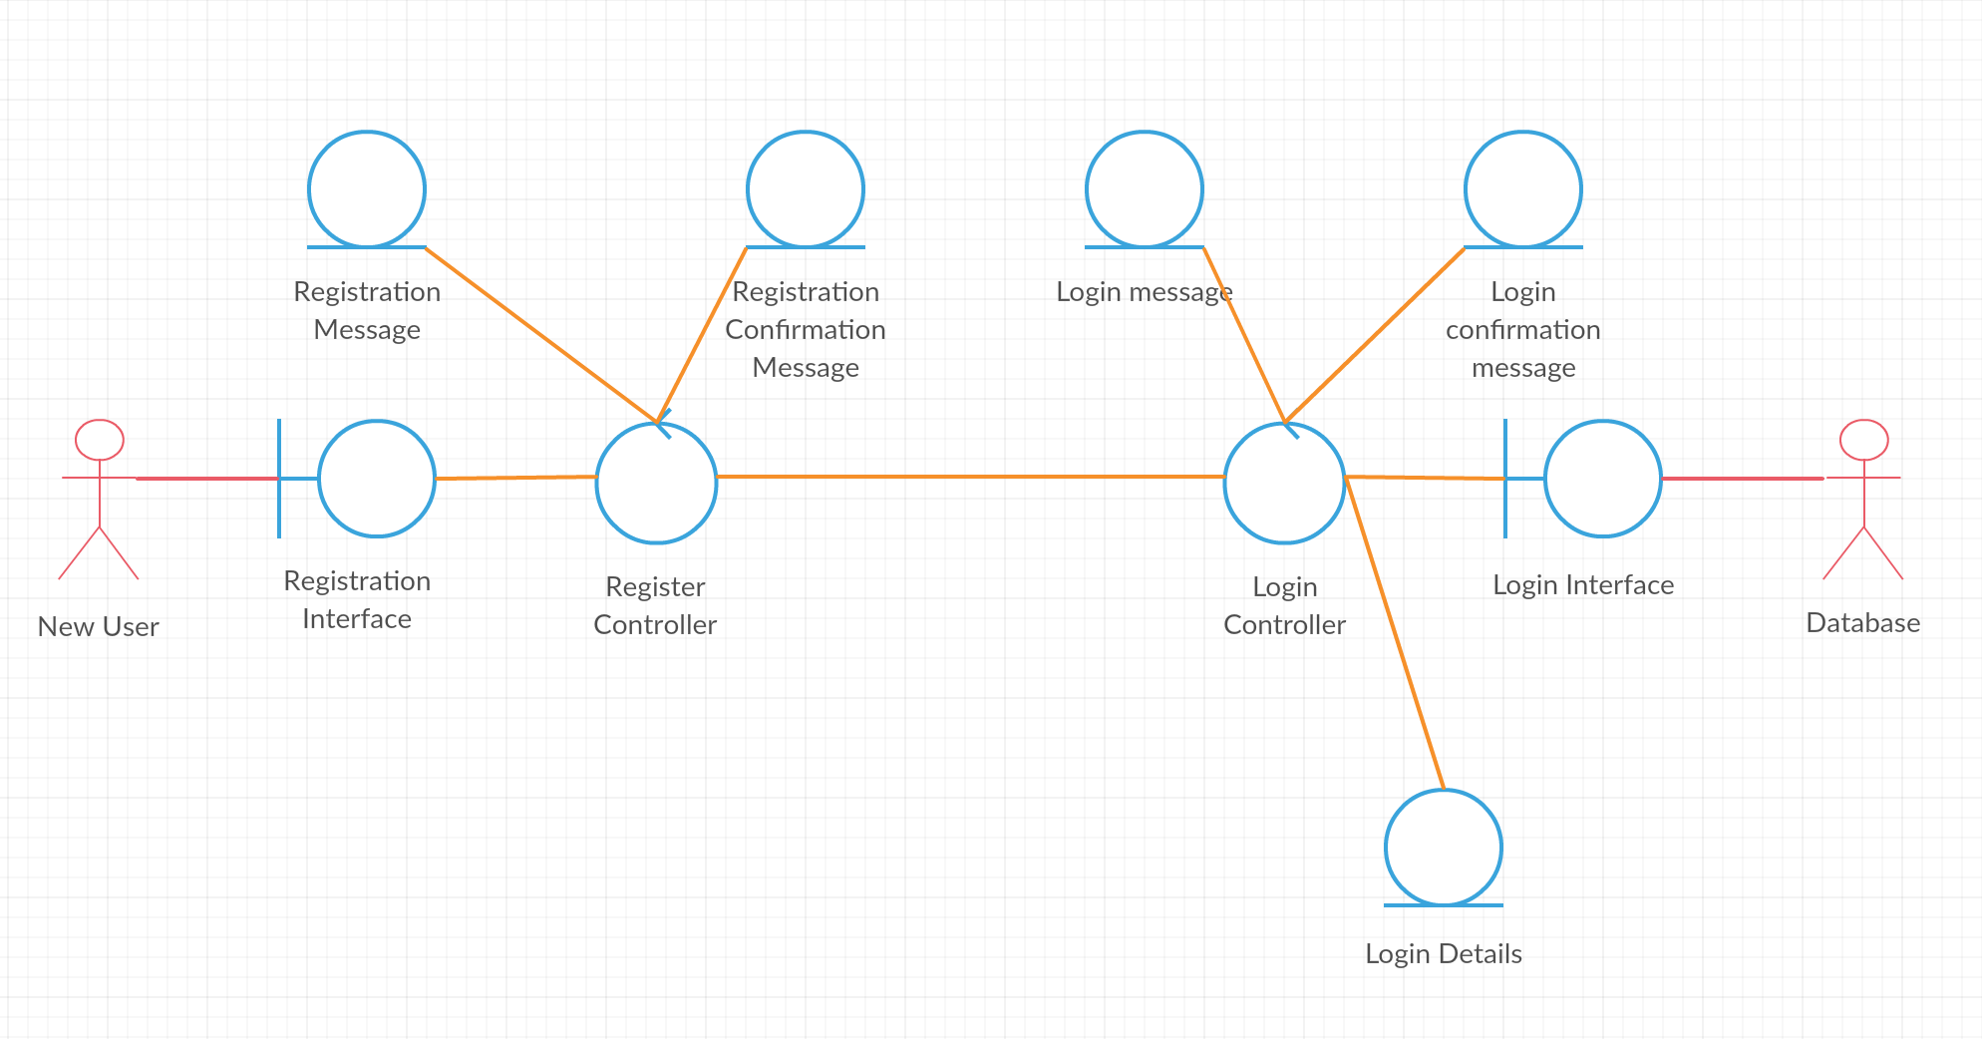

## Login

## Enter Poll Information

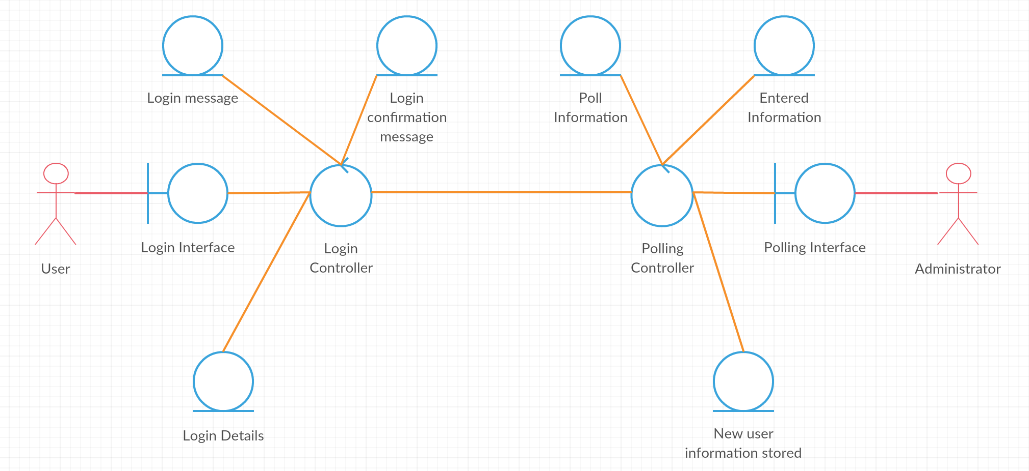

## Enter Poll Information

## View Poll

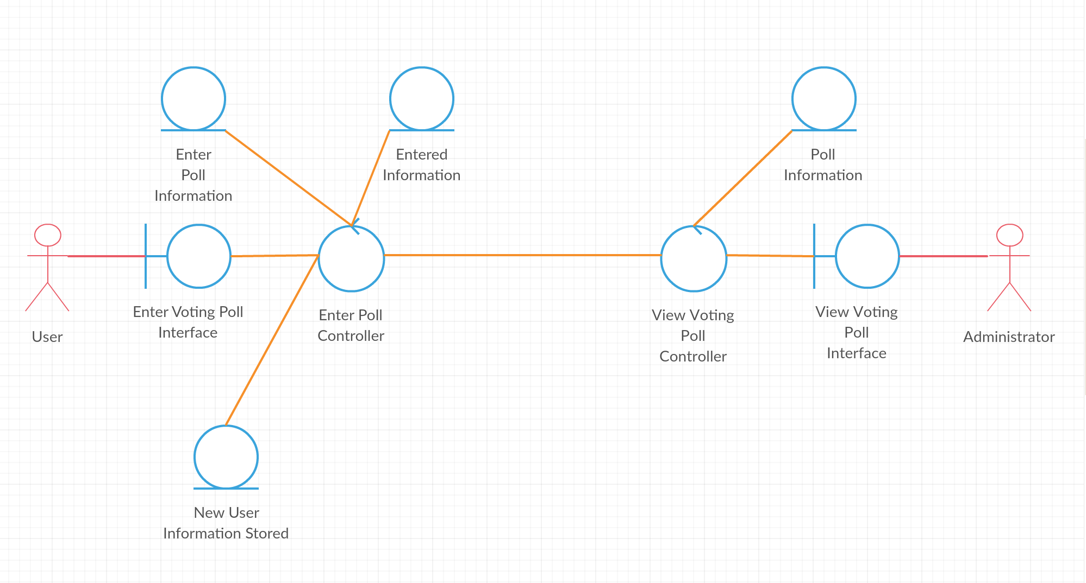

# Improper Sequence Diagram

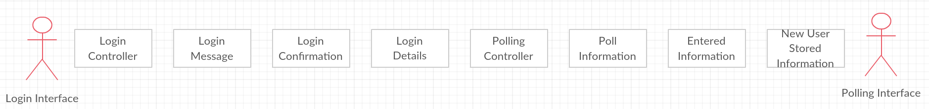

# Sequence Diagram

